**Application: Ethiopia COVID-19 Response Team**

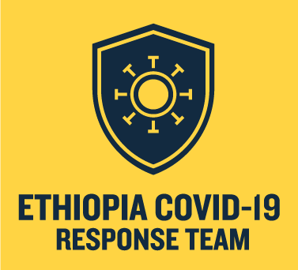

Ethiopia COVID-19 Response Team UCSF Rosenman ADAPT

**Summary**

**ID:** 4827219887

**Application Form - UCSF Rosenman ADAPT**

### 1) Please enter contact information.

**Make sure you enter the contact information for the person we should communicate with**

**concerning all necessary actions and feedback during the UCSF Rosenman ADAPT program.**

Email : salemdebebe80@gmail.com

First Name : Salem

Last Name: Moges

Company Name: ECRT

Country: United States

Address (No response)

City (No response)

State/Province : California

Zip/Postal Code (No response)

Phone Number (No response)

Company Website (No response)

### 2) What is the name and email address of the company's founder? (If there is more than one founder, please list all)

### Mike Endale mike@ethiocovid19rt.com

### 3) List founder's professional bio (make sure to include: background, role, and full-time/part- time status). If more than one founder, please list information for all.

### ECRT: Mike Endale: Role - Tech Lead Background - Software Engineering Profession - Tech Startup Founder / Software Development

### 4) Select the number of full-time employees.

**20 +**

### 5) What best describes the industry sector for your technology?

**Medical Devices and healthcare services**

### 6) Describe your technology (50 words max).

The Ethiopia COVID-19 Response Team is a global volunteer team of engineers, doctors, designers, marketers, architects, product managers, and other industry professionals. The team’s goal is to introduce the premiere local manufacturing, advanced training and maintenance protocol in Ethiopia and throughout Africa.

### 7) What patient population can you reach with your product/service? (50 words max).

Our initiatives are focused on medical devices used in all government hospitals throughout Ethiopia. This can potentially impact over 70% of the patient population.

### 8) Describe in detail how you would spend the $150,000 offered by the ADAPT program. (% R&D, personnel, marketing, production, distribution, etc.)? (100 words max).

80% of medical devices in developing countries are donated and 40% are non-functional. PPE, oxygen therapy and ventilators are in severe shortage in Ethiopia.

ECRT is working on addressing these issues via local manufacturing, training, better maintenance practices and supplying parts needed.

Tegbareid Polytechnic College and their team of biomedical engineers in Ethiopia partnered with ECRT to provide training, to repair and maintain medical devices.

Establishing a standard guidelines to use before procuring medical devices is also one of ECRT’s goals.

The $150,000 would be distributed accordingly: local manufacturing (60%); training (25%); supplying parts (10%) and establishing maintenance protocol (5%).

### 9) What stage is your company at?

* Idea/concept stage
* Product under development
* Prototype ready
* Completed pre-clinical study
* Product ready

### 10) Total capital raised to date (type and amount, e.g. $200K F&F or $5M Series A, etc.).

$25,000 from lifebox.org

Reliability testing Grant($$$)

### 11) Who would be a useful partner/collaborator to expedite the deployment of your technology? Check all that apply.

* Echo Health Ventures (maybe health related information, to provide training)
* UnitedHealth Group ( maybe health related information, to provide training)
* Express Scripts
* Amazon Web Services
* Other, please specify...

### 12) How did you hear about the UCSF Rosenman ADAPT program?

**No Responses Selected**

### 13) Is your company incorporated?

**No**

### 14) Are any of your founders or key employees minorities? (This is for internal information and does not affect the status of your application)

**Yes**

3 / 4

### 15) Are any of your founders or key employees women? (This is for internal information and does not affect the status of your application)

**YESSS**

### 16) Are you affiliated with the University of California? This is for our internal information only and does not affect the status of your application.

**No**